1. Create a web page which contains the fields like Fname, Lname, age, address, City. Have the radio buttons and check box as per your respective design.

Use JSPs, CSS and JSTL tags. Also write simple Javascript method to validate the above fields.

!DOCTYPE html>

<html>

   <head>

      <title>Angular JS Forms</title>

      <script src = "https://ajax.googleapis.com/ajax/libs/angularjs/1.3.14/angular.min.js"></script>

      <style>

         table, th , td {

            border: 1px solid grey;

            border-collapse: collapse;

            padding: 5px;

         }

         table tr:nth-child(odd) {

            background-color: #f2f2f2;

         }

         table tr:nth-child(even) {

            background-color: #ffffff;

         }

      </style>

   </head>

   <body>

      <h2>AngularJS Sample Application</h2>

      <div ng-app = "mainApp" ng-controller = "studentController">

         <form name = "studentForm" novalidate>

            <table border = "0">

               <tr>

                  <td>Enter first name:</td>

                  <td><input name = "firstname" type = "text" ng-model = "firstName" required>

                     <span style = "color:red" ng-show = "studentForm.firstname.$dirty && studentForm.firstname.$invalid">

                        <span ng-show = "studentForm.firstname.$error.required">First Name is required.</span>

                     </span>

                  </td>

               </tr>

               <tr>

                  <td>Enter last name: </td>

                  <td><input name = "lastname"  type = "text" ng-model = "lastName" required>

                     <span style = "color:red" ng-show = "studentForm.lastname.$dirty && studentForm.lastname.$invalid">

                        <span ng-show = "studentForm.lastname.$error.required">Last Name is required.</span>

                     </span>

                  </td>

               </tr>

               <tr>

                  <td>Age: </td><td><input name = "age" type = "age" ng-model = "age" length = "30" required>

                     <span style = "color:red" ng-show = "studentForm.age.$dirty && studentForm.age.$invalid">

                        <span ng-show = "studentForm.age.$error.required">Age is required.</span>

                     </span>

                  </td>

               </tr>

               <tr>

                  <td>Address: </td><td><input name = "address" type = "address" ng-model = "address" length = "100" required>

                     <span style = "color:red" ng-show = "studentForm.address.$dirty && studentForm.address.$invalid">

                        <span ng-show = "studentForm.address.$error.required">Address is required.</span>

                     </span>

                  </td>

               </tr>

               <tr>

                  <td>City: </td><td><input name = "address" type = "city" ng-model = "city" length = "100" required>

                     <span style = "color:red" ng-show = "studentForm.city.$dirty && studentForm.city.$invalid">

                     </span>

                  </td>

               </tr>

               <tr>

                  <td>

                     <button ng-click = "reset()">Reset</button>

                  </td>

                  <td>

                     <button ng-disabled = "studentForm.firstname.$dirty &&

                        studentForm.firstname.$invalid || studentForm.lastname.$dirty &&

                        studentForm.lastname.$invalid || studentForm.age.$dirty &&

                        studentForm.age.$invalid || studentForm.address.$dirty &&

                        studentForm.address.$invalid || studentForm.city.$dirty &&

                        studentForm.city.$invalid" ng-click="submit()">Submit</button>

                  </td>

               </tr>

            </table>

         </form>

      </div>

      <script>

         var mainApp = angular.module("mainApp", []);

         mainApp.controller('studentController', function($scope) {

            $scope.reset = function() {

               $scope.firstName = "Sanju";

               $scope.lastName = "Kuriakose";

               $scope.age = 23;

               $scope.address="Pambrakaran(H)";

               $scope.city="Perumbavoor";

            }

            $scope.reset();

         });

      </script>

   </body>

</html>

Output:

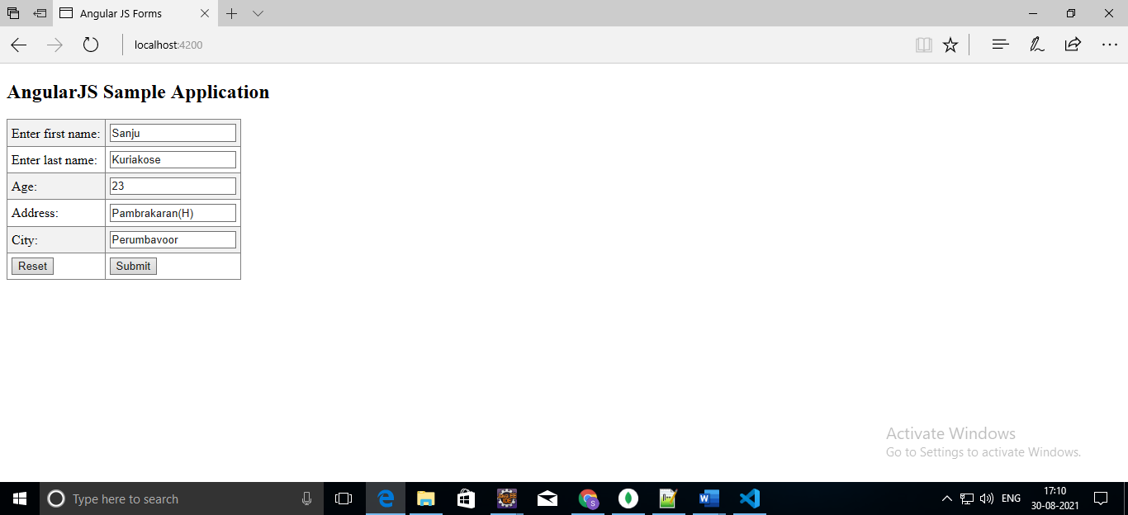

1. Write a standalone class to show how to connect to the Database(mysql) from Java application.

**package** com.db.ust;

**import** java.sql.Connection;

**import** java.sql.DriverManager;

**import** java.sql.ResultSet;

**import** java.sql.Statement;

**public** **class** DBConnect {

**public** **static** **void** main(String[] args) {

**try** {

Class.*forName*("com.mysql.jdbc.Driver");

Connection con=DriverManager.*getConnection*("jdbc:mysql://localhost:3306/sample","root","root");

Statement stmt=con.createStatement();

ResultSet rs=stmt.executeQuery("select * from emp");

**while**(rs.next())

System.***out***.println(rs.getInt(1)+" "+rs.getString(2)+" "+rs.getString(3));

con.close();

}

**catch**(Exception e) {

System.***out***.println(e);

}

}

}

Output:

1 ABC 30

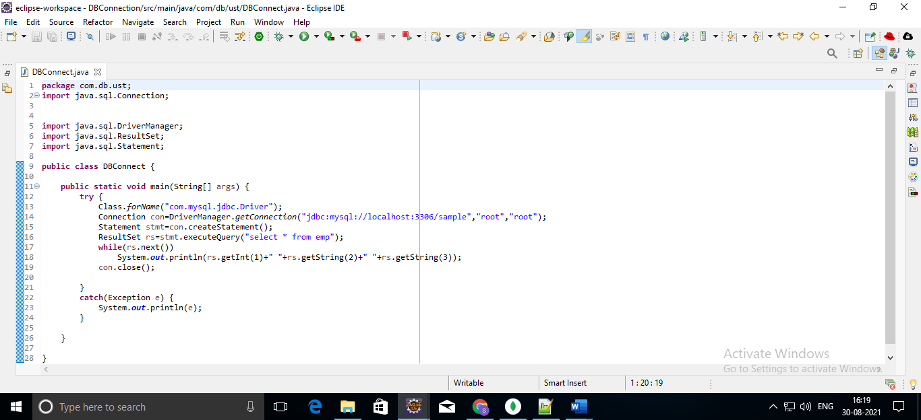

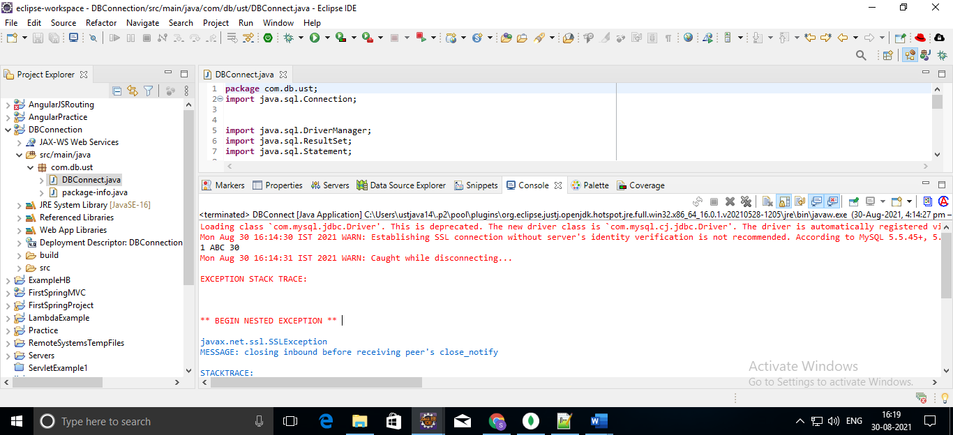

1. Create simple web pages using Angular Js and React Components.



